🧭 Classification of Homophones
# Source: AI Source: Provided by: [Data Path: Persons Table -> ID Column: 1, Name_En Column: Motasem Essam] -> From: [ChatGPT] on [8/1/2025]
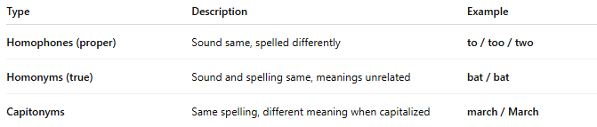
Type | Description | Example
Homophones (proper) | Sound same, spelled differently | to / too / two
Homonyms (true) | Sound and spelling same, meanings unrelated | bat / bat
Capitonyms | Same spelling, different meaning when capitalized | march / March

